**UI Info:**

**1.WelCome Screen**

User have to enter Author name and author type in this field which will reflect in every activity user do. So, no need to enter all the details again and again.

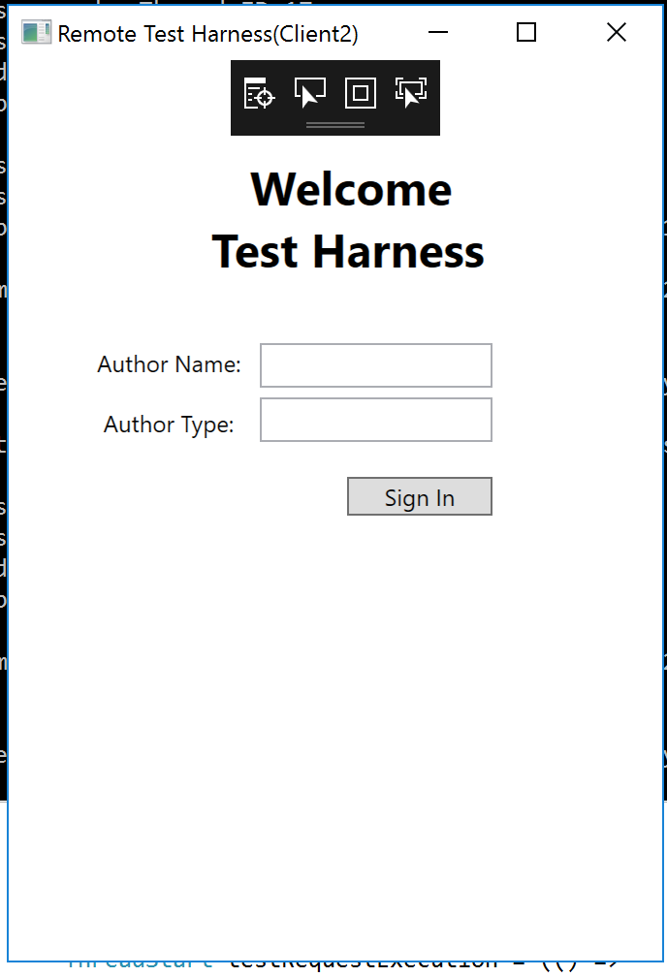

**2. Test Harness Activity Screen**

It has four tab. One of the tab is visible in the screenshot. You can select test drivers and codes in test element. You can add as much element as you can. But, after adding other adding other element, you can’t change the details of element you have entered previously.

Like this screenshot, previous one get disabled once new test element get added since we are capturing that data into our variable.

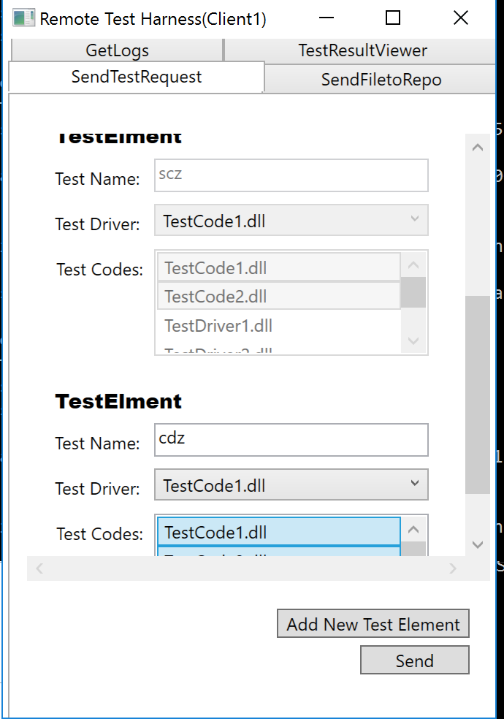

There are three other tabs as seen in the above screenshot:

**GetLogs**

You can search the logs by just keywords. You have to enter some keywords related to that log files. It will return name of all the log files related to that keyword. Then, user have to select one of them, and click on getlog button.

**TestResultViewer**

**\*\*NOTE**-It shows the aggregate result of all the test element which you have sent in one test request.So, if one of the test element’s test got failed, then whole test request result or status will be failed.**

You can click on one of them, and click on getlog button, which will give you the logs of that test request.

**SendFileToRepo**

It is very important tab since we can send dlls from client to repository using this tab. It is os much imporatant because in first screen, while adding test request, user have functionality to select test driver and test codes from the list. This list is getting populated by **BROWSING THE REPOSITORY. IF REPOSITORY HAS NO FILE, USER CAN NOT SEND TEST REQUEST TO TEST HARNESS. CLIENT HAS TO FIRST UPLOAD HIS/HER DLL TO THE REPOSITORY, THEN AND THEN IT WILL BE POPULATED AS TEST DRIVER AND TEST CODES IN FIRST TAB(SendTestRequest).**